Network Protocol Research - Bitcoin
CYBR3010
Cybersecurity Foundations

Arr Domingo
Student ID: 200458099
December 15, 2025

Instructor: Sam El-Awour
Table of Contents
1 Introduction 1
2 Bitcoin – general description 1
2.1 What is Bitcoin network protocol 1
2.2 RFC Reference(s) 2
2.3 How and why the protocol is used 2
2.4 Prevalence of the protocol 3
2.5 When was the protocol developed? 4
2.6 How many revisions or versions are there? 4
2.7 Protocol vulnerabilities 6
2.8 Security issues/flaws 7
2.9 Common attacks 8
2.10 Mitigation Strategies 9
3 Port number(s) used by the protocol 10
4 Header Structures and Fields 11
4.1 Describe all fields 11
5 Functionality of the protocol 12
5.1 Options 12
5.2 Response Codes 13
6 Sample Communications 14
6.1 Message 14
6.1.1 “version” message 15
6.1.2 “tx” (transaction) message 16
6.2 Handshake 16
7 Packet capture output 17
7.1 Open Wireshark to capture the traffic: 17
7.2 Set-up Bitcoin Core: 18
7.3 Screenshots of bitcoin packet capture in Wireshark 20

Introduction
Network protocol is a set of rules for formatting and processing data, which is like a common language for computers. The computers within a network may use vastly different software and hardware, however, the use of protocols enables them to communicate with each other regardless. As an analogy, think of two people from different parts of the world, they may not understand each other's native languages, but they can communicate using a shared third language. On the Internet, there are different protocols for different types of processes. But in this document, it provides a clear context on a protocol called Bitcoin. As you progress through, this document will outline the functionality and security issues related to bitcoin network protocol as well as on attacks against their vulnerabilities.

Bitcoin – general description

2.1 What is Bitcoin network protocol
The Bitcoin protocol is a decentralized and peer‑to‑peer network protocol used to manage the transfer, verification, and recording of digital currency known as Bitcoin. It defines how nodes communicate, how transactions are structured, how blocks are validated, and how consensus is achieved. Bitcoin as a payment network operates without the intervention of any central authority. It is established on a distributed register, for which each user keeps a version of it, and which defines an overview of all user accounts. Bitcoin is also the name of the protocol that determines the rules of operation of the network. It is the software used by the nodes to take part in the payment system.
To a layperson, bitcoin is a digital currency that is created and held electronically. These bitcoins are sent and received using a mobile app, computer software, or service provider that provides a bitcoin wallet. The wallet generates an address, akin to a bank account number, except that a Bitcoin address is a unique alphanumeric sequence of characters where the user can start to receive payments. Usually, bitcoins may be obtained by buying them at a Bitcoin exchange as payment for goods and services.

2.2 RFC Reference(s)
Bitcoin is not standardized by the IETF, so it does not have RFC. Its reference specification is the Bitcoin Whitepaper by Satoshi Nakamoto (2008) and the open‑source Bitcoin Core implementation.

2.3 How and why the protocol is used
How bitcoin protocol works:
- Peer-to-Peer Network: Transactions are broadcast directly between users, not through a central server.
- Blockchain & Ledger: All transactions are recorded on a public, shared, immutable ledger (the blockchain).
- Mining & Consensus: Miners bundle transactions into "blocks," solve complex math problems (Proof-of-Work), and add them to the chain, earning new bitcoins and fees; this consensus mechanism validates transactions and secures the network.
- Cryptography: Digital signatures (using public/private keys) prove ownership and authorize transactions, preventing forgery.
- Decentralization: No single entity controls the network, rules are enforced by the collective agreement of the nodes.
Why is the bitcoin protocol used:
- Decentralized Payments: Enables sending money globally, 24/7, without banks or intermediaries, often cheaper and faster for international transfers.
- Store of Value (Digital Gold): Its limited supply (capped at 21 million coins) makes it attractive as a hedge against inflation, like gold.
- Censorship Resistance: Transactions are difficult for governments or banks to block or reverse.
- Investment & Speculation: Bought and traded on exchanges as an asset.

2.4 Prevalence of the protocol
The Bitcoin protocol has achieved significant global prevalence. Below is from June 2025 data from the internet article, “How Many People Own Crypto in the World?”.
- 562 million people worldwide own cryptocurrency.
- 6.8 % of the global population holds crypto assets.
- 1.29% of the world’s population owns Bitcoin, or about 106 million people.
- Men make up 61% of global crypto owners.
- Women account for 39% of all cryptocurrency holders.

2.5 When was the protocol developed?
- October 31, 2008: Bitcoin whitepaper released.
- January 3, 2009: First implementation (Bitcoin v0.1).
- 2009–present: Continuous updates via Bitcoin Core.

2.6 How many revisions or versions are there?
The table below lists some notable versions of the P2P network protocol, with the most recent versions listed first.
Table 1. Bitcoin protocol versions.
Version | Initial Release | Major Changes
70015 | Bitcoin Core 0.13.2 (Jan 2017) | New banning behavior for invalid compact.
70014 | Bitcoin Core 0.13.0 (Aug 2016) | Added sendcmpct, cmpctblock, getblocktxn, “blocktxn” messages. Added “MSG_CMPCT_BLOCK” inventory type to “getdata” message.
70013 | Bitcoin Core 0.13.0 (Aug 2016) | Added “feefilter” message. Removed “alert” message system. See Alert System Retirement.
70012 | Bitcoin Core 0.12.0 (Feb 2016) | Added “sendheaders” message.
70011 | Bitcoin Core 0.12.0 (Feb 2016) | Filter messages are disabled without NODE_BLOOM after and including this version.
70002 | Bitcoin Core 0.9.0 (Mar 2014) | Send multiple “inv” messages in response to a “mempool” message if necessary and added “reject” message.
70001 | Bitcoin Core 0.8.0 (Feb 2013) | Added “notfound” message. Added “filterload” message. Added “filteradd” message. Added “filterclear” message. Added “merkleblock” message and added relay field to “version” message. Added “MSG_FILTERED_BLOCK” inventory type to “getdata” message.
60002 | Bitcoin Core 0.7.0 (Sep 2012) | Added “mempool” message. Extended “getdata” message to allow download of memory pool transactions.
60001 | Bitcoin Core 0.6.1 (May 2012) | Added nonce field to “ping” message. Added “pong” message.
60000 | Bitcoin Core 0.6.0 (Mar 2012) | Separated protocol version from Bitcoin Core version.
31800 | Bitcoin Core 0.3.18 (Dec 2010) | Added “getheaders” message and “headers” message.
31402 | Bitcoin Core 0.3.15 (Oct 2010) | Added time field to “addr” message.
311 | Bitcoin Core 0.3.11 (Aug 2010) | Added “alert” message.
209 | Bitcoin Core 0.2.9 (May 2010) | Added checksum field to message headers, added “verack” message, and added starting height field to “version” message.
106 | Bitcoin Core 0.1.6 (Oct 2009) | Added transmitter IP address fields, nonce, and User Agent (subVer) to “version” message.

2.7 Protocol vulnerabilities
Core Protocol/Network Vulnerabilities:
- Quantum Computing: Future quantum computers could break the ECDSA used for signing, making all current Bitcoin vulnerable.
- Selfish Mining/Block Withholding: Miners secretly mine blocks and release them strategically to gain more rewards, potentially slowing the network.
- Liveness Denial: A liveness attack is an extremely serious high-severity vulnerability that can lead to a temporal or permanent shutdown of a blockchain network. The validators form an internal conspiracy to execute this attack. They unanimously agree to stop producing blocks, and the blockchain stops.
- Denial of Service (DoS): Bugs allowing attackers to crash nodes or consume excessive CPU/memory, often through crafted network messages or inefficient queue handling.
- Resource Exhaustion: Issues causing disk space filling (e.g., via invalid blocks in logs) or memory leaks.
Software-Specific Vulnerabilities (CVEs):
- Disk-filling vulnerabilities: Issues where an attacker could cause a node to fill up its disk space through excessive logging of spoofed connections or invalid blocks (e.g., CVE-2025-54604, CVE-2025-54605).
- Transaction-relay jamming: Off-chain protocol attacks that can delay or prevent the propagation of certain transactions across the network (e.g., CVE-2024-55563).
- Denial-of-Service via malformed messages or large inputs: Numerous past and present CVEs have addressed ways in which an attacker could crash or stall a node by sending specially crafted network messages.

2.8 Security issues/flaws
- Private Key Management: Losing your private key means losing your Bitcoin forever; it's your sole access.
- Phishing/Social Engineering: Hackers trick users into revealing keys or sending funds.
- Endpoint Security: Storing keys on insecure computers or devices makes them vulnerable to malware.
- Exchange Hacks: Centralized exchanges holding user funds are prime targets for hackers, leading to massive losses.
- Regulatory Gaps: Lack of consistent regulation leaves users unprotected compared to traditional banking.
- Illicit Use: Bitcoin's irreversibility and pseudonymous nature attract criminal activity, impacting the ecosystem's reputation.

2.9 Common attacks
- 51% Attack: This occurs when a single entity or group gains control of more than 50% of the network's mining hash rate. The attacker can manipulate the blockchain by preventing transactions from being confirmed, reversing transactions, and potentially double-spending coins.
- Double Spending Attack: This involves the same Bitcoin being spent multiple times. Attackers can try to convince the network that a transaction is legitimate while secretly using the same coins elsewhere. This undermines the integrity of the cryptocurrency and can lead to financial losses for merchants and users.
- Sybil Attack: An attacker creates multiple fake identities (nodes) to gain disproportionate influence over the network. This can lead to disruptions in transaction processing and may allow the attacker to alter the network's consensus.
- Eclipse Attack: An attacker takes control of a target node's view of the network by isolating it from the rest of the network and feeding it false information. This can enable the attacker to manipulate transactions and potentially carry out double-spending attacks.
- Denial of Service (DoS) Attack: An attacker floods the network with excessive requests or malicious data, overwhelming nodes and disrupting service. This can lead to slower transaction processing times and reduce the overall reliability of the network.
- Selfish Mining Attack: Miners exploit their advantage by withholding mined blocks from the network to gain a competitive edge over others. This can lead to a concentration of power among a few miners and affect the fairness of the mining process.
- Transaction Malleability Attack: An attacker alters the transaction ID before it is confirmed, causing confusion about the transaction status. This can lead to double spending and complications in tracking transactions, impacting user trust.

Mitigation Strategies
- Increasing Network Hash Rate: A higher overall hash rate makes it more difficult for any single entity to gain a majority control over the network. Encouraging more miners to join the network and using more efficient mining hardware can help achieve this goal.
- Use of Mining Pools: Mining pools allow multiple miners to combine their hashing power, increasing the chances of successfully mining blocks. By joining mining pools, smaller miners can compete effectively and reduce the risk of 51% attacks.
- Improved Transaction Confirmation Techniques: Using multiple confirmations for significant transactions can help prevent double spending and increase security. Setting a higher confirmation threshold for larger transactions can provide added assurance.
- Network Protocol Improvements: Updating the Bitcoin protocol to address vulnerabilities can enhance security against specific attacks. Regularly reviewing and upgrading the protocol to implement security patches and improvements can safeguard the network.
- Decentralized Governance and Protocol Upgrades: A decentralized governance model allows the community to collectively make decisions about protocol changes and upgrades. Engaging the community in discussions and decisions regarding network upgrades can enhance security and adaptability.
- Incentivizing Full Nodes: Full nodes help maintain the network's integrity by validating transactions and blocks independently. Providing incentives for users to run full nodes can increase the network's decentralization and security.

3 Port number(s) used by the protocol
Port 8333 is the default port for Bitcoin Core peer-to-peer network communication. Bitcoin nodes use this port to communicate with other nodes in the blockchain network, synchronizing transactions and blocks. A system with this port open is likely running Bitcoin mining or full node software.
Other port numbers used are:
- 18333 - The default TCP port for the Bitcoin testnet.
- 18444 - The default TCP port for the Bitcoin regtest (regression testing) network.
- 8332 - The default TCP port for the Bitcoin Core JSON-RPC (Remote Procedure Call) interface, used for local or authenticated remote control of the node.

4 Header Structures and Fields
The header contains a summary of the message, and its structure is the same for every message in the Bitcoin protocol. Here's what a header looks like for a "version" message. The “version” message provides information about the transmitting node to the receiving node at the beginning of a connection. Until both peers have exchanged “version” messages, no other messages will be accepted.
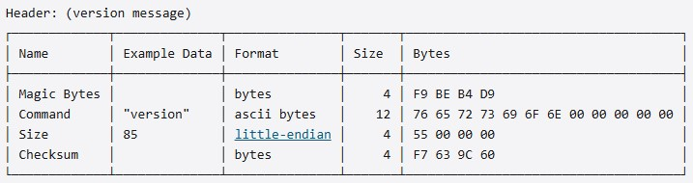
Figure 1. Header structure of a version message.

4.1 Describe all fields
- Magic Bytes: This is a unique set of bytes used to identify the start of a new message. They're always the same. You'll be reading a stream of bytes from your TCP connection when receiving messages, so it's handy to be able to identify when a new message starts. This random-looking set of bytes has been specifically chosen so that it's unlikely that they would appear anywhere else in a message.
- Command: This indicates the type of message being sent. You can send different types of messages in the Bitcoin protocol, and they contain different types of information. It's a 12-byte field containing the ASCII encoding the name of the message type. The one in this example says that we are sending a "version" message, which is used to send information about ourselves to another node.
- Size: This is the size of the upcoming payload (contains the main content of the message). This indicates how many bytes you need to read from the socket to get the full message being sent.
- Checksum: This is a small fingerprint for the payload. It allows us to quickly check that the data in the payload hasn't been tampered with during transit. It's created by double-hashing the payload, then taking the first 4 bytes of the result.

5 Functionality of the protocol

5.1 Options
In the Bitcoin protocol, “options” doesn’t mean user-configuration options like in HTTP. Instead, it usually refers to capabilities, features, or flags that nodes advertise and negotiate when they connect. These are service flags advertised in the version message that allow nodes to choose compatible peers.
- NODE_NETWORK: Node can serve full blocks and the full blockchain
- NODE_GETUTXO: Supports UTXO set queries (rarely used)
- NODE_BLOOM: Supports bloom filters (SPV clients)
- NODE_WITNESS: Supports Segregated Witness (SegWit)
- NODE_NETWORK_LIMITED: Can serve recent blocks only
Segregated Witness (SegWit) Option separates signature data from transaction data, reduces transaction malleability, increases effective block capacity, advertised using NODE_WITNESS. Nodes that don’t support SegWit can still operate but won’t validate witness data.

5.2 Response Codes
The Bitcoin protocol does not use numeric response codes like HTTP (200, 404, etc.). Instead, it uses message-based responses in its peer-to-peer (P2P) protocol. Bitcoin nodes communicate using request/response messages over TCP. Each request has a corresponding response message, not a numeric code.
Example:
- Request: getdata
- Response: tx or block
Table 2. Common positive response message types
Request Message | Response Message | Purpose
version | Verack (version acknowledge) | Acknowledges protocol version
ping | pong | Confirms peer is alive
getaddr | addr / addrv2 | Returns known peer addresses
getdata | tx, block, headers | Sends requested data
getblocks | inv | Advertises available blocks
getheaders | headers | Sends block headers
mempool | inv | Lists unconfirmed transactions

On the other hand, there is also error and negative response such as “notfound” message. This is used when requested data cannot be provided.
Example:
- Request: getdata (block hash)
- Response: notfound

6 Sample Communications

6.1 Message
A message is a structured piece of data that Bitcoin nodes send to each other over the network. They all have the same format.
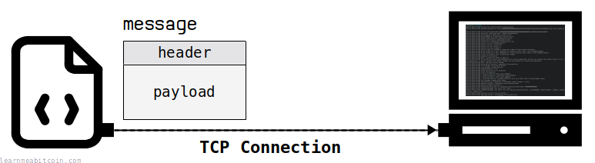
Figure 2. Bitcoin message consists of header and payload, uses TCP for communication and usually runs on port 8333.

6.1.1 “version” message
A “version” message is the first message received that provides information about the transmitting node to the receiving node at the beginning of a connection. Until both peers have exchanged “version” messages, no other messages will be accepted.
Figure 3. Sample communication – version message.
Explanation of the sample communication:
- f9beb4d9 (green highlight) – this is the start magic bytes
- 76657273696f6e… (yellow highlight) – this is the command for version message
- 4aae42a4… (red highlight) - this is the truncated hex

6.1.2 “tx” (transaction) message
A “tx” (transaction) message in the Bitcoin protocol is a network message used to send a single, complete, unconfirmed transaction to a connected peer. It is a fundamental part of how transactions propagate across the peer-to-peer network.
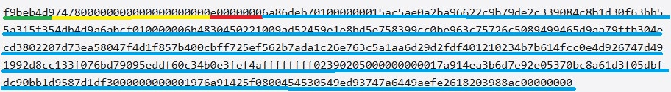
Figure 4. Sample communication – tx message.
Explanation of the sample communication:
- f9beb4d9 (green highlight) – this is the start magic bytes
- 7478000000000000000000 (yellow highlight) – this is the command for tx message
- e0000000 (red highlight) – this is a serialized transaction
- 6a86deb7… (blue highlight) – this is the truncated hex

6.2 Handshake
Before receiving data, handshake is performed. Handshake is the process that establishes communication between two networking devices. This handshake is just a sequence of messages sent each other to get the ball rolling. Below is how handshake works for bitcoin protocol.
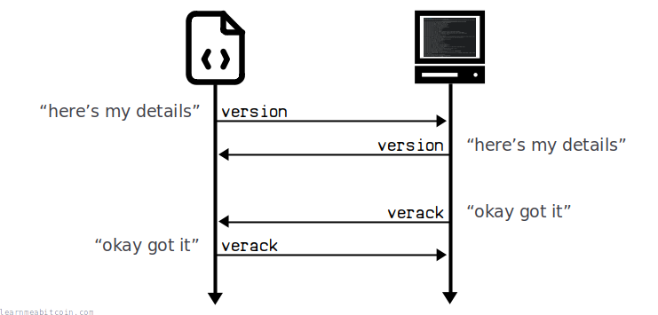
Figure 5. Bitcoin handshake.
So, the handshake is basically a 2-step process:
- We initiate the communication by sending our "version" message, and they respond with their own "version" message.
- They then send a "verack" message acknowledging that they've received our version message, and we finish by sending a "verack" message back to them. A “verack” is a simple message header without a payload.

7 Packet capture output

7.1 Open Wireshark to capture the traffic:
- Open Wireshark.
- Select Network Interface. This is usually the interface that shows active traffic (indicated by a fluctuating graph). If the wallet is connecting to other processes on the same computer, you may need to select a "loopback" interface.
- Click the "Start" button (the shark fin icon) to begin capturing packets.

7.2 Set-up Bitcoin Core:
- Go to https://bitcoincore.org/en/download/ and download “Linux (tgz)”.
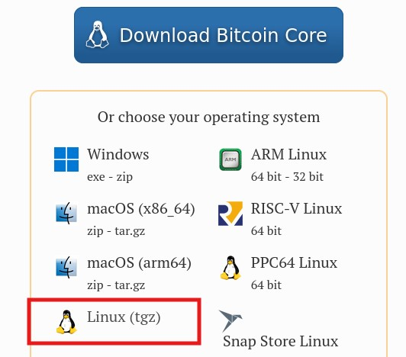
Figure 6. Linux bitcoin core installer.
- Extract the folder.
- Open the extracted folder. Go to bin. Right-click and choose open terminal here.
- Run command “ls” to check the files. Make sure “bitcoin-qt” file is present.
- Run command “chmod +x bitcoin-qt” to make it executable.
- To launch bitcoin wallet, run command “./bitcoin-qt”.
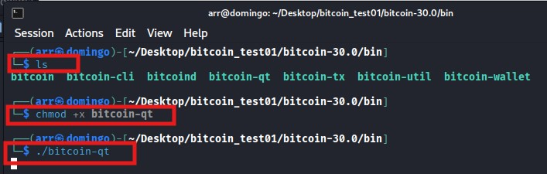
Figure 7. Command for Bitcoin Core.
- “Welcome to Bitcoin Core” dialog box will appear, choose the default data directory and click OK.
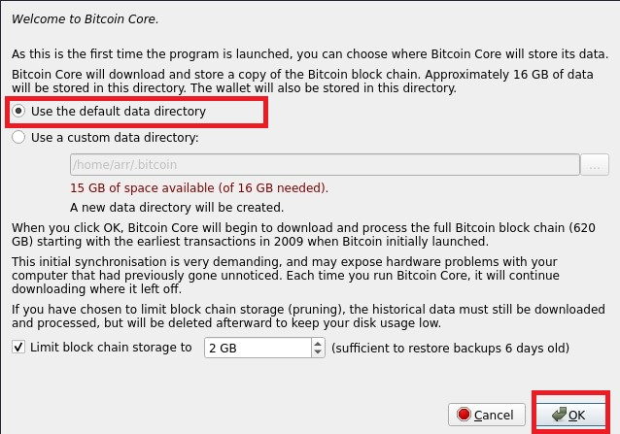
Figure 8. Welcome dialog box.
- Another dialog box will appear, click “Hide”.
- Perform an action, such as sending a transaction, to generate network traffic. But for this simple demonstration, just create a new wallet.
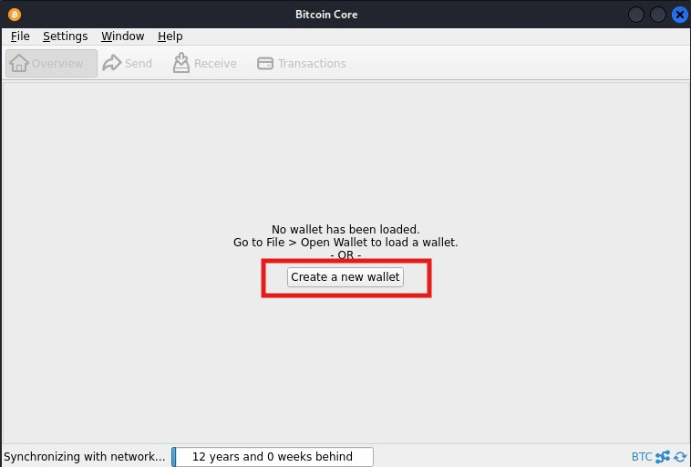
Figure 9. Create new wallet in Bitcoin Core.
- Enter wallet name. Click “Create”.
- From this point, stop the capture in Wireshark.
- You can use a display filter in Wireshark to isolate the Bitcoin-specific traffic. A common filter would be tcp.port == 8333 or simply using the built-in bitcoin protocol filter if available in your version of Wireshark.
- You can then inspect the packets in detail, viewing information such as the transaction (tx) or block messages exchanged between your node and other peers on the network.

7.3 Screenshots of bitcoin packet capture in Wireshark
Below are screenshots of bitcoin protocol in Wireshark.
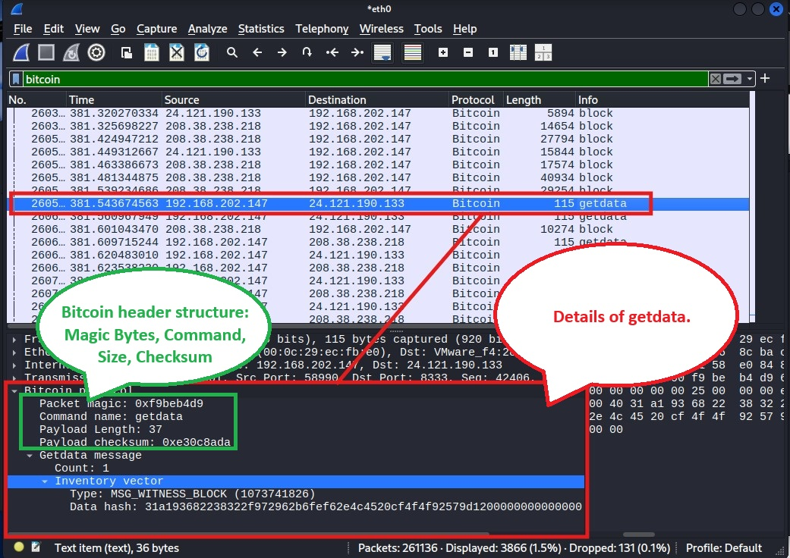
Figure 10. Bitcoin packet getdata.
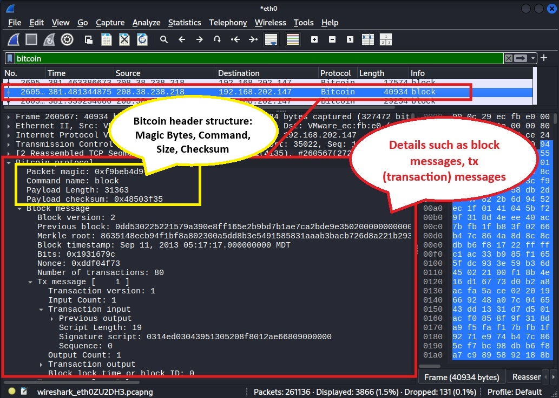
Figure 11. Block message and tx (transaction) message.

References

Blockchain Security: Common Vulnerabilities and How to Protect Against Them. (2025, June 30). Retrieved from Hacken: https://hacken.io/insights/blockchain-security-vulnerabilities/
Kemmerer, D. (2025, June 10). How Many People Own Crypto in the World? - June 2025 Data. Retrieved from CoinLedger: https://coinledger.io/research/how-many-people-own-crypto-in-the-world
Mitigating Attacks in Bitcoin. (2025, July 23). Retrieved from geeksforgeeks: https://www.geeksforgeeks.org/computer-networks/what-are-bitcoin-mitigating-attacks/
Morel2, L. (2025, September 18). Bitcoin: What is it? Retrieved from Bitstack: https://www.bitstack-app.com/en/learn-bitcoin/bitcoin-what-is-it?c=EUR
P2P Network. (n.d.). Retrieved from bitcoindeveloper: https://developer.bitcoin.org/reference/p2p_networking.html
Port 8333 – BITCOIN (Bitcoin Protocol). (n.d.). Retrieved from PentestPad: https://www.pentestpad.com/port-exploit/port-8333-bitcoin-bitcoin-protocol
Security Advisories. (n.d.). Retrieved from BitcoinCore: https://bitcoincore.org/en/security-advisories/
Walker, G. (2025, August 11). Magic Bytes. Retrieved from learnmeabitcoin: https://learnmeabitcoin.com/technical/networking/magic-bytes/
Walker, G. (2025, August 27). Networking. Retrieved from learnmeabitcoin: https://learnmeabitcoin.com/technical/networking/
What is a protocol? | Network protocol definition. (n.d.). Retrieved from Cloudflare: https://www.cloudflare.com/learning/network-layer/what-is-a-protocol/

